**Candidate Take Home Assignment**

**Problem**: Given a file containing a json of permissions, parse the contents and create a csv with column marked 1 if found in user, 0 if not

Example JSON

{

    "student1": [

        "view_grades",

        "view_classes"

    ],

    "student2": [

        "view_grades",

        "view_classes"

    ],

    "teacher": [

        "view_grades",

        "change_grades",

        "add_grades",

        "delete_grades",

        "view_classes"

    ],

    "principle": [

        "view_grades",

        "view_classes",

        "change_classes",

        "add_classes",

        "delete_classes"

    ]

}

Example output CSV

        ,  view_grades, change_grades, add_grades, delete_grades, view_classes, change_classes, add_classes, delete_classes,

student1,       1,              0,           0,           0,            1,              0,           0,           0,

student2,       1,              0,           0,           0,            1,              0,           0,           0,

teacher,        1,              1,           1,           1,            1,              0,           0,           0,

principle,      1,              0,           0,           0,            1,              1,           1,           1,

**Bonus point 1: If u can do it in python or PHP**

**Bonus Point 2: if u can leverage Google API to create a spreadsheet**

Phone interview：

Bootstrap，GitHub

1. 算法题：**Reverse a string but if the letter repeat 3 or more times in a row skip it in the results**
   * **Sample Input: aabccccdda**
   * **Sample Output: addbaa**

On-site面试问过的问题：

爬虫：爬虫如何实现，如何找到那个位置（xpath,jquary）

如果同时发request要求爬东西，怎办（用queue）

Django：url的问题；get/post区别；建model用migration；

Orm怎么query。

算法题；1,linked-list找中点，

2给一个target，求pair的平方和等于target

3 给一个有向图，求里面的cycle有多少个

4 有一排student，每个人有一个grade（ABCDF）教师发糖，限制是1，每个人最少一个，每个人拿的糖要跟他旁边的人比，旁边的人grade比他高，要比他拿的多，比他低，要比他拿的少。问教师最少发出去多少糖

5 给一个matrix，求连续k个数的sum的最大值。八个方向都叫连续

In a directed graph, find number of circuits (ending node same as starting node, nodes can repeat, edges cannot). Input anything that can describe the graph. For example, a list of edges with 2 nodes, starting and end point, or a list of Nodes with referenced neighboring Nodes.

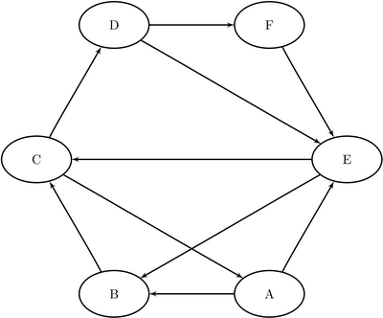

E.g. (A,B) is a directed edge. (A,B,C,A) and (A,B,C,D,E,C,A) are circuits. (A,B,C,A) and (B,C,A,B) are the same and count as 1.

Input = [(A,B), (B,C), (C,A) ….]

Alt_input = {A: (B, E), B: (C), C: (A, D), … }

From collections import deque

Def circ(alt_input):

For node in alt_input:

hash ={}

Stack = deque()

stack.append({node:()})

While stack:

Ele = stack.pop()

#If no stack

For temp in alt_input[ele]:

stack.append({temp:(ele,temp)}

Suppose we have an N x M matrix as shown below.

Write a function/program that returns the largest sum of K consecutive digits, where K=4.  The  algorithm should check for largest sum:

1. Horizontally,

2. Vertically,

3. Diagonally, in both directions TL -> BR, TR -> BL

Matrix =

---------------------

| 1   1   1   0   2 |

| 5   1   2  9*  1 |

| 8   0   9*  0   4 | N

| 3   9*  3   5   0 |

| 9*  2   4   0   6 |

---------------------

         M

[1,1,1,0,2]

# returns 36

Def  getLargestSum(matrix):

ans=float(‘-inf’)

For i in range(n):

Ans = max(ans, large_sum(4,matrix[i]))

For j in range(n):

Array =

Def large_sum(k,array):

Res = sum(array[:k])

For i in range(0,len(array)-4):

         # [1,1,1,0,2]

res  = max(res,res-array[i]+array[i+4])

Return res